

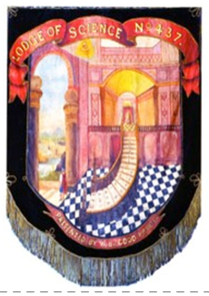

**Please book Menu choices** through W Bro Kevin Aldred

Email: [aldred.k@sky.com](mailto:aldred.k@sky.com) Mob: 07792 806367

**Lodge of Science No 437 Ladies Night 2022**

The Worshipful Master Don Cochrane and his wife Mandy

invite you to a Ladies Night at the Grange at Oborne

on Saturday 12th November 2022 – 6:30pm for 7:00pm

**£45 Per Person, Black Tie**

**Charity Stewards Raffle** – All proceeds will go towards the

Worshipful Master’s Charities for the Year:

* Prostate Cancer UK
* Wincanton Food Bank
* Somerset & Dorset Animal Rescue

**Preferred Payment** via BACS by Sat 22nd October 2022

Masonic Lodge of Science 437

60-04-33

60720522

Ref: LN – *Your Name*

**Alternative Payment** Cash or Cheque made out to Lodge of Science

to W Bro Lee Osborn by Sat 22nd October 2022

Music and Dancing to TJ Entertainment

**Family, Friends, Neighbours are all welcome**

**Remember to book your Menu choices** through W Bro Kevin Aldred

Email: [aldred.k@sky.com](mailto:aldred.k@sky.com) Mob: 07792 806367

**Accommodation**: All the rooms are being held for the Masonic function, so call or email to secure a room:

The Grange at Oborne, Sherborne, Dorset, DT9 4LA

T: 01935 813463 [reception@thegrange.co.uk](mailto:reception@thegrange.co.uk)

The following B&B room rates apply:

Standard Double £74 - Superior Double £94 - Deluxe £114